**Name: Bhavika Tanaji Ghadage.**

**PRN: 2019BTECS00049**

**Batch: T6**

**Sub: Programming Lab 3**

**Assignment No.3**

**Problem Statement 1:**

Install different web browsers on your machine. Go through the Developer Tools option of the browser.

**Problem Statement 2:**

1. Visit https://en.wikipedia.org/wiki/Computer_science on various browsers.

**On Microsoft edge:**

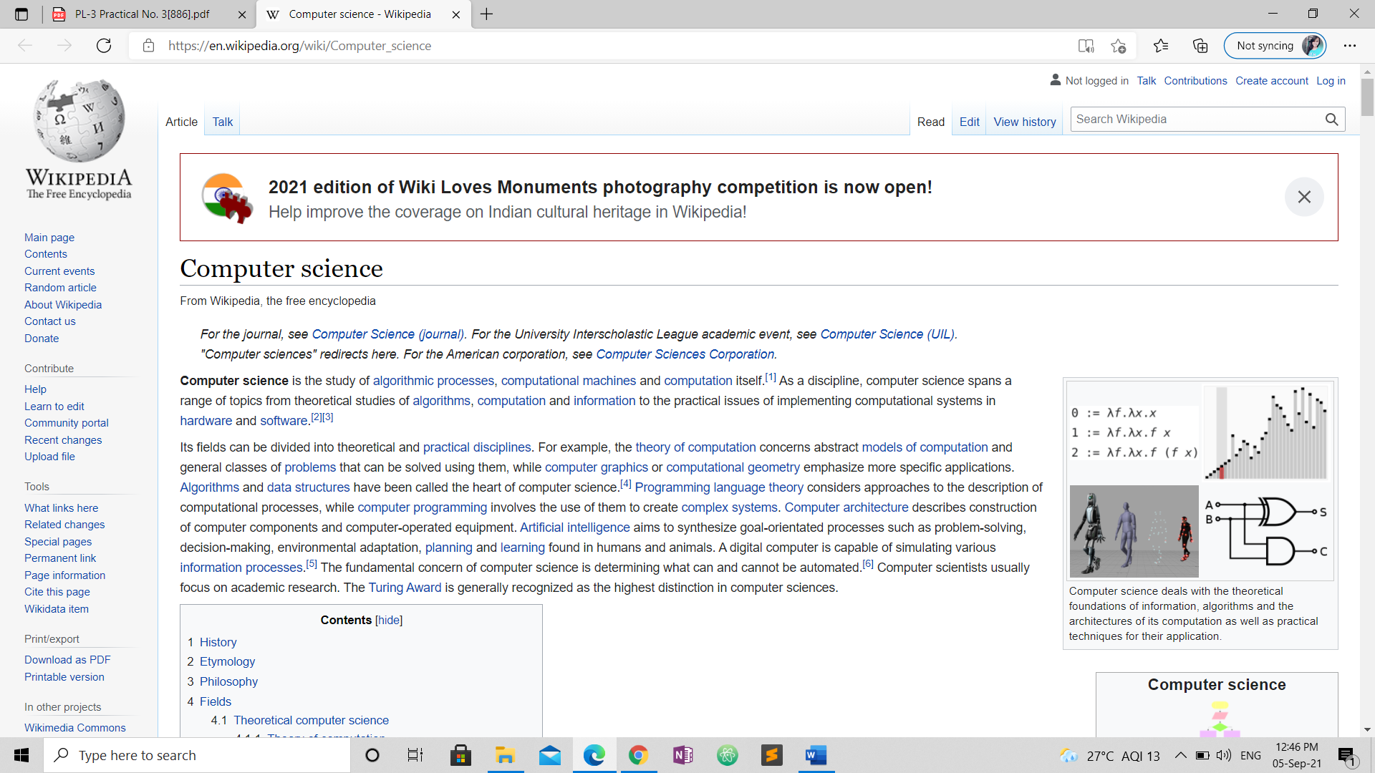

**On Google chrome:**

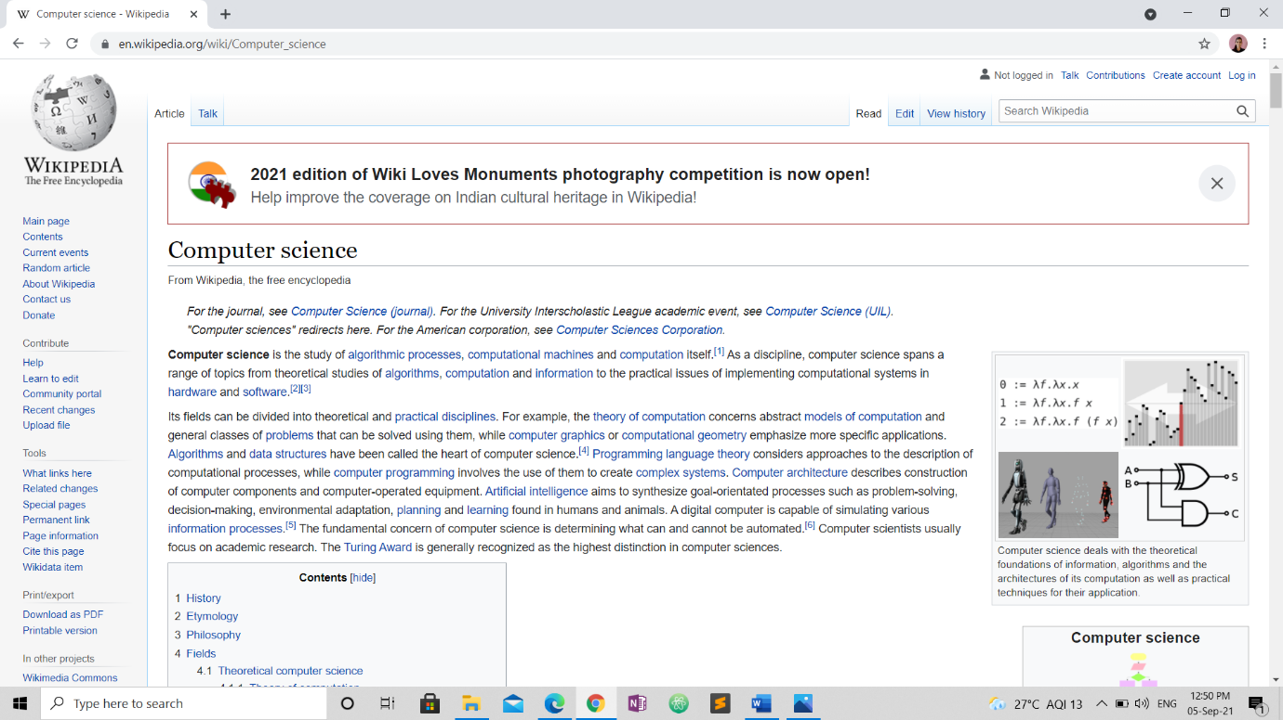

1. Using browser’s Developer Tools option find out how many requests-response cycles are needed to load the page fully on your machine?

**On Microsoft edge:**

**Process:**

1. Go to developer tool option
2. Look for network option if not found search in more tab option
3. Click on network
4. Request will be there

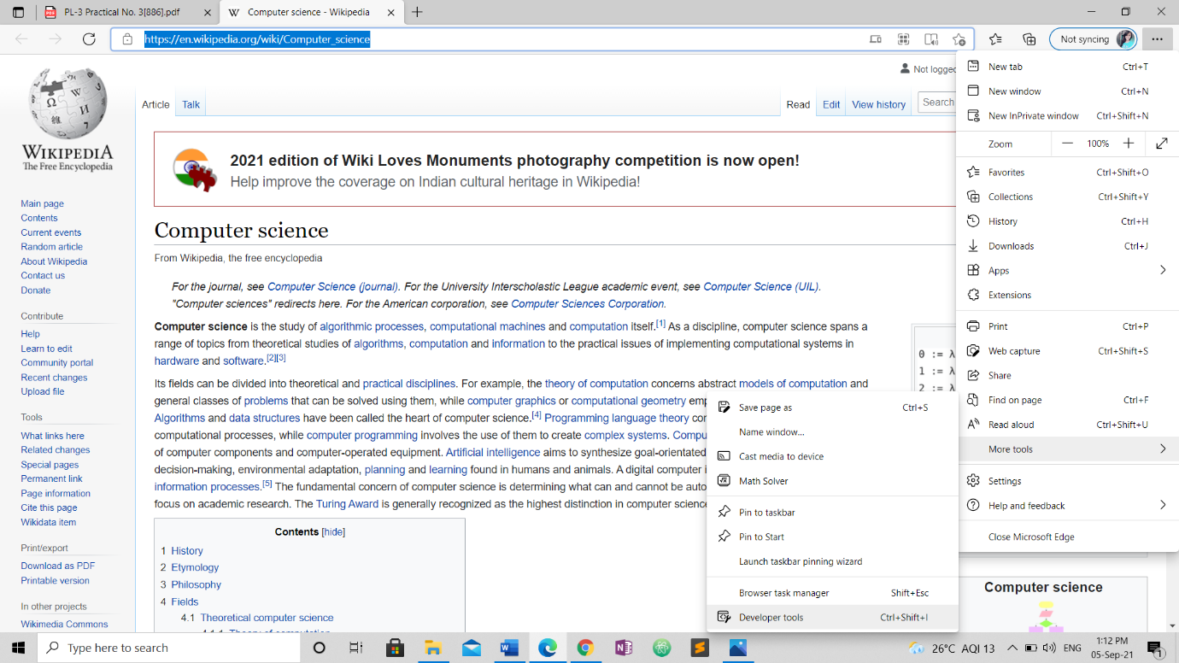

There are 115 request cycles are needed to load the page fully on machine.

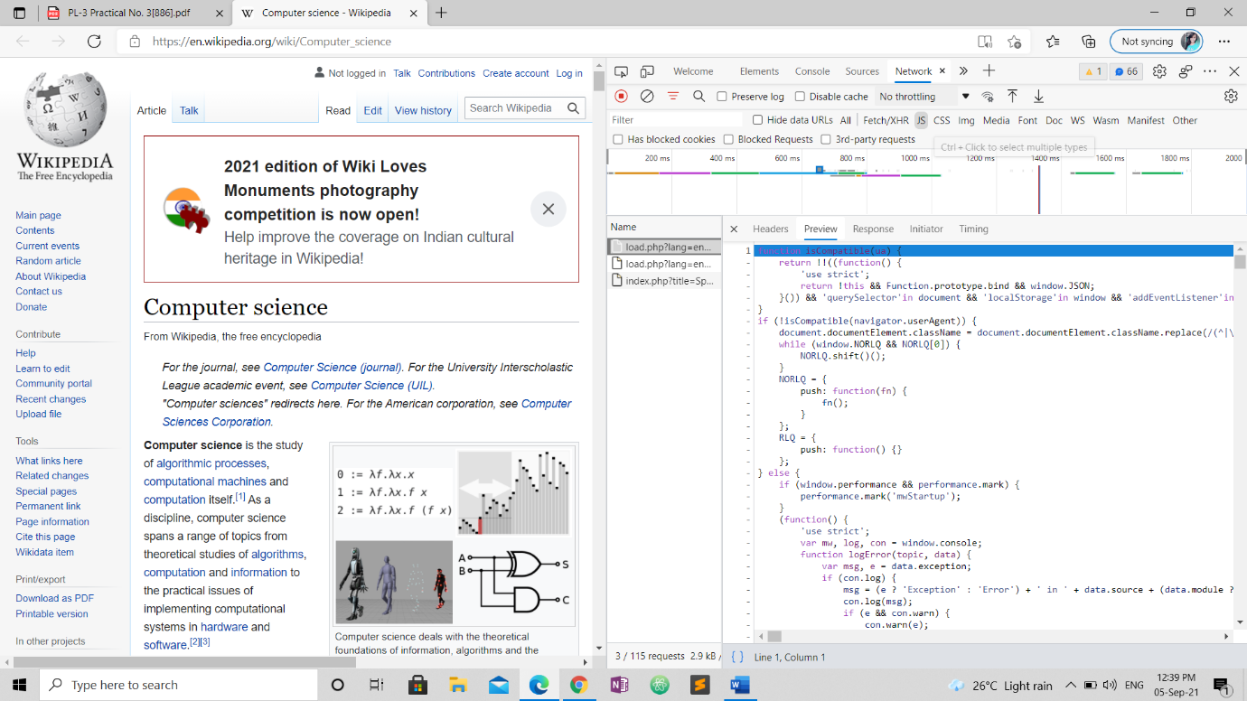

**On Google chrome:**

**Process:**

1. Go to developer tool option
2. Look for network option if not found search in more tab option
3. Click on network
4. Request will be there



There are 112 request cycles are needed to load the page fully on machine

3. Using browser’s Developer Tools option get the header information of the page.

**On Microsoft edge:**

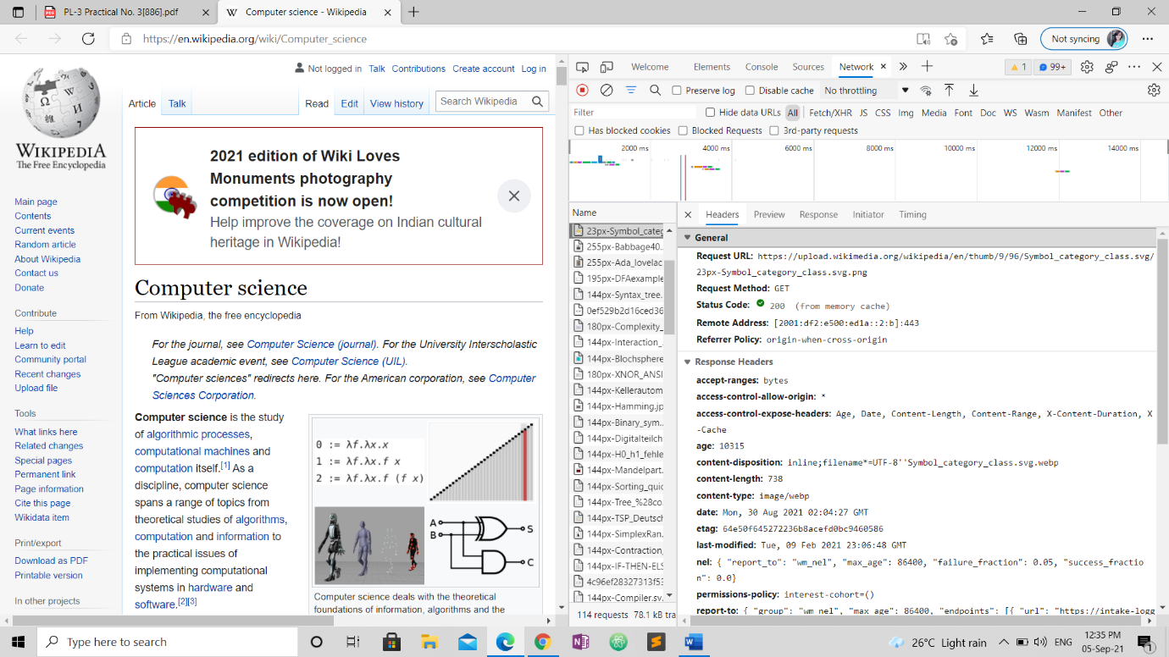

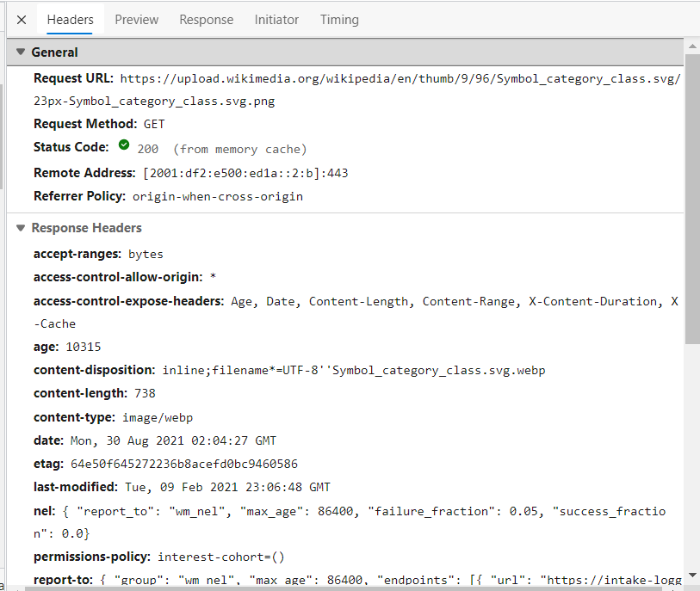

**On Google Chrome:**

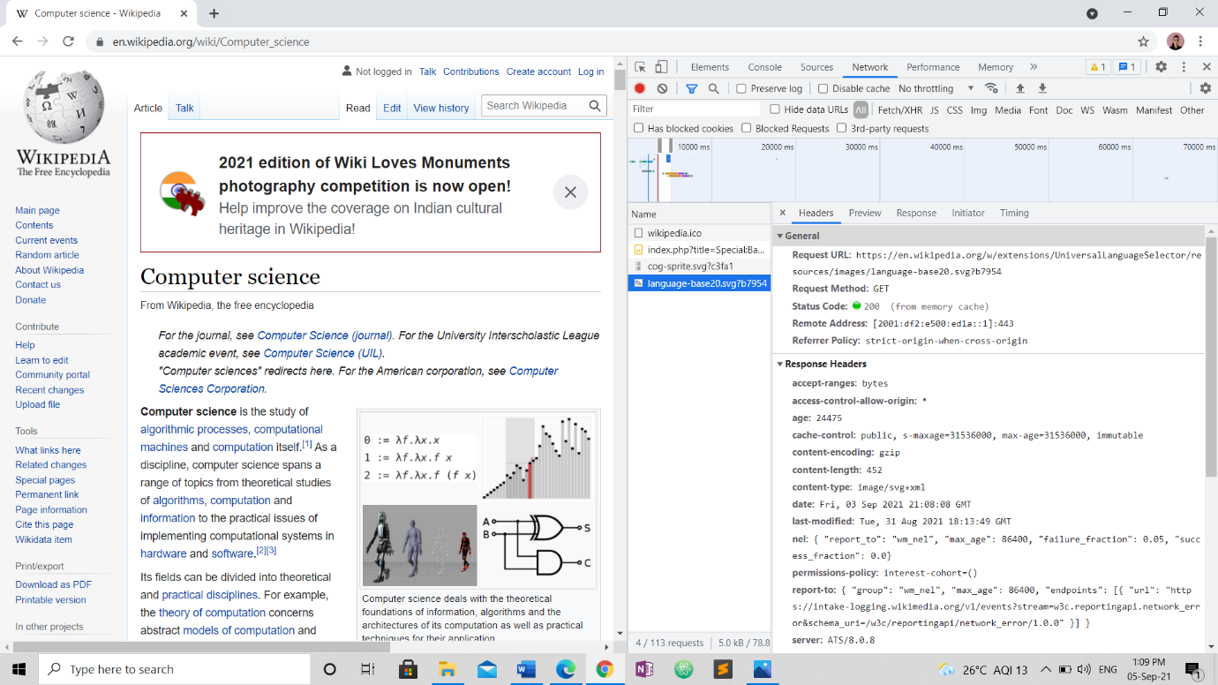

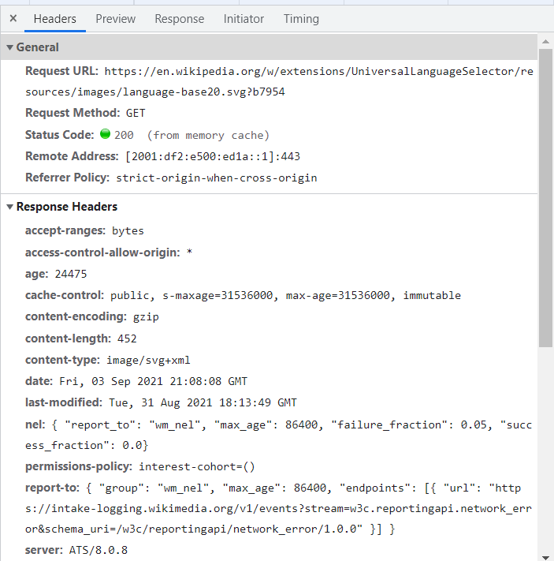

4.Using browser’s Developer Tools option go through the DOM, CSS editor and JavaScript debugger options.

**On Microsoft edge:**

DOM:

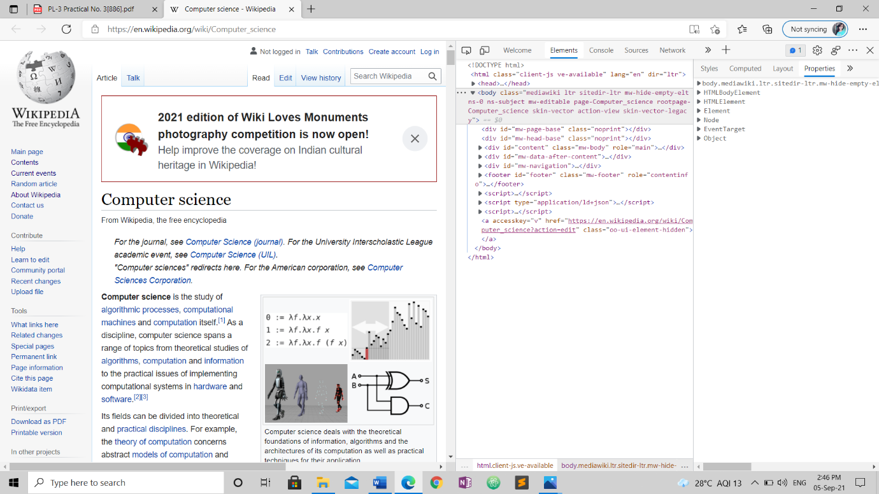

CSS editor:

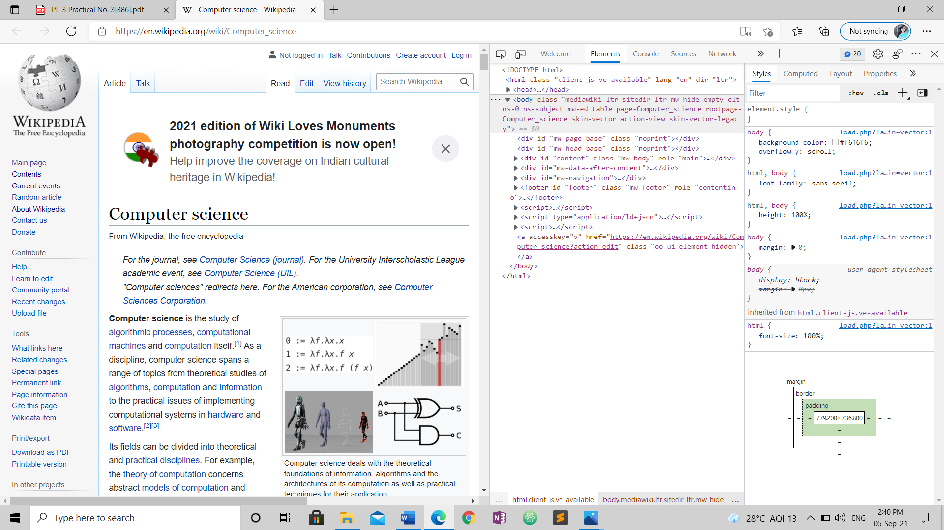

JavaScript debugger:

